NET BANKING

The project aims to establish a highly secure and efficient Internet banking system accessible to all customers with valid user IDs and passwords. Its primary goal is to empower customers to conduct crucial transactions from the convenience of their current location without the need to physically visit a bank.

The initiative is designed to seamlessly integrate with the existing banking system, stramlining customer-bank interactions. By leveraging real-time technology, the project offers a robust internet-based platform, simplifying and expediting banking operations.

**1. Introduction**

Welcome to the Net Banking Application! This manual is designed to help users navigate and utilize the features of our secure and user-friendly banking platform. It allows customers to perform banking transactions online conveniently from anywhere.

### Key Features:

* 24/7 accessibility
* Secure fund transfers
* Real-time updates on account activities.

## 2. Login and Registration1000092209.jpg

### Registration:

1. Open the application or website.
2. If you are a new user first register yourself with your details. Click on **Register.**
3. Fill in the required details:

* Full Name
* Date of Birth
* Email
* Address
* Mobile Number

Give your details in this format:

Name:DOB:Email:Address:Mobile Number

1. Set a secure password..
2. Log in using your credentials.

### Login:

1. Open the app or website.
2. Click **Login** to access your dashboard
3. Enter your Username and Password.

## 3. Features and Functionalities

### Home Page:

The Home Page provides quick access to all the primary functionalities of the application. It includes the following options:

1. **Profile:**
   * Selecting this option navigates you to the **Profile Management** page, where you can view, update, or delete your profile details.
2. **Account:**
   * Choosing this leads to the **Account Management** page for tasks such as account creation, viewing account details, and account deletion.
3. **Transaction:**
   * Takes you to the **Transaction Management** page, where you can transfer money, check your balance, and view transaction history.
4. **Checkbook Request:**
   * Navigate here to request a new checkbook. Specify the type and number of leaves required.
5. **Logout:**

* Logs you out securely and redirects you to the login page.

### Profile Management: 1000039951.jpg

1. **View Profile:**

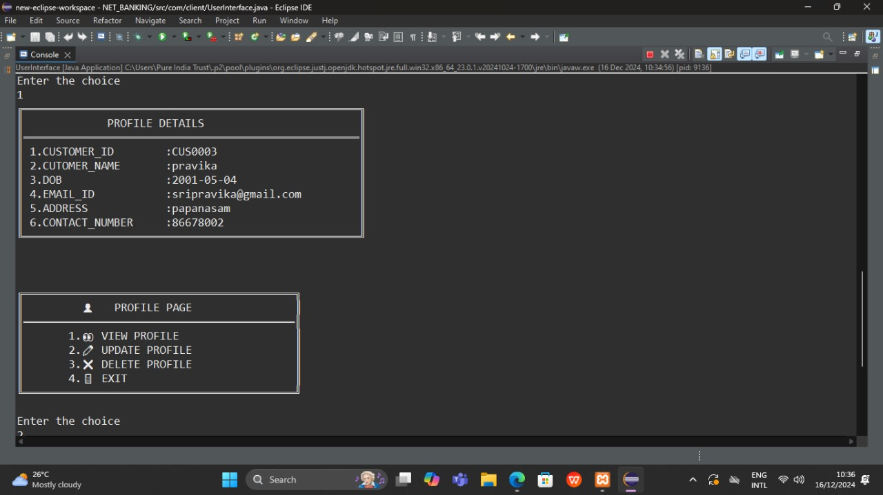

* + Navigate to **Profile**.
  + View details like Name, Email, and Contact Information.

1. **Update Profile:**

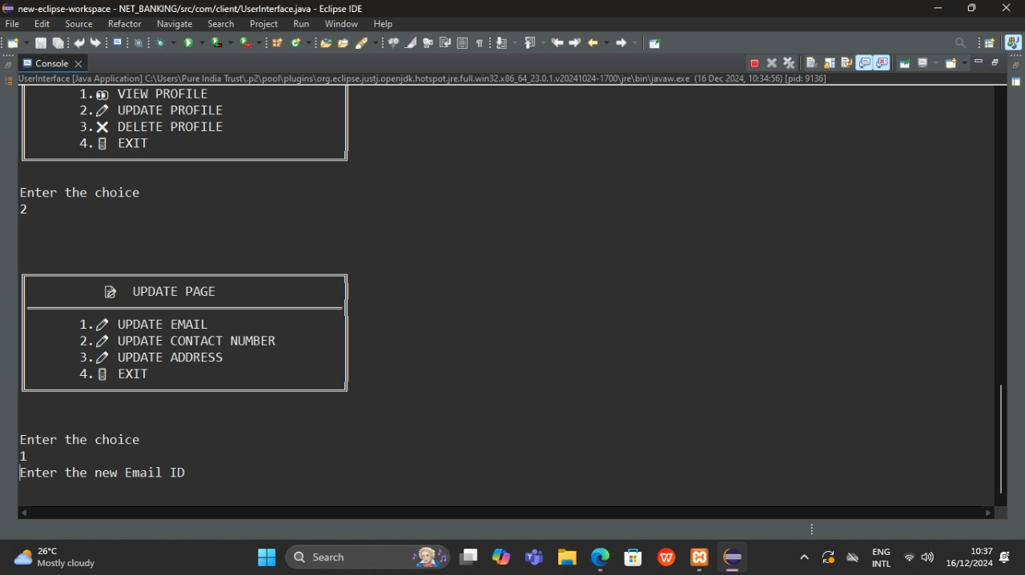

* Go to **Update Profile**.
* Selecting this option will redirect you to the **Update Page**.
* On the Update Page, you can:
  1. **Update Email:** Modify your registered email address and save changes.
  2. **Update Contact Number:** Change your phone number securely.
  3. **Update Address:** Update your residential or correspondence address and confirm the changes.

1. **Delete Profile:**
   * Select **Delete Profile**.
   * Confirm the action to remove your profile permanently.
2. **Exit to Home Page:**

* Select **Exit** to return to the home page.

### Account Management:

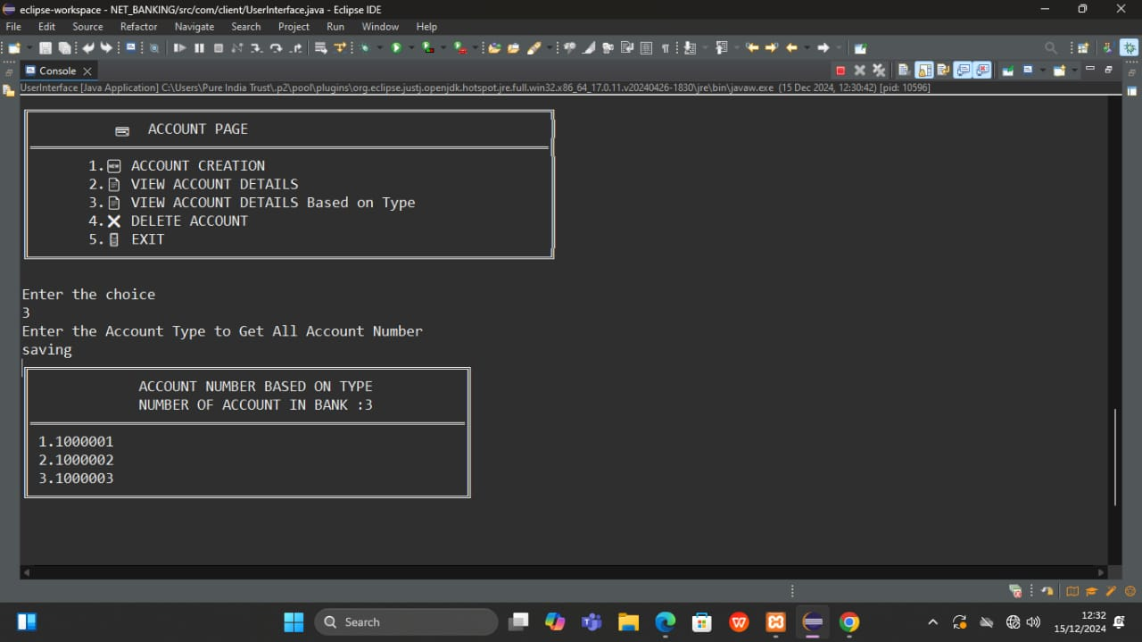

1. **Account Creation:**
   * Go to **Account Management**.
   * Select **Create Account** and fill in the necessary details.
2. **View Account Details:**
   * Navigate to **View Account Details**.
   * Access information such as account type and balance.

3. **View Account Details Based On Type:**

* Access Account Number associated with the account type and Count of all users holding accounts under the same type (Saving/Deposit).

**4. Delete Account:**

* + Select **Delete Account** under **Account Management**.
  + Confirm the action to remove the account.

1. **Exit to Home Page:**
   * Select **Exit** to return to the home page.

### Transaction Management:

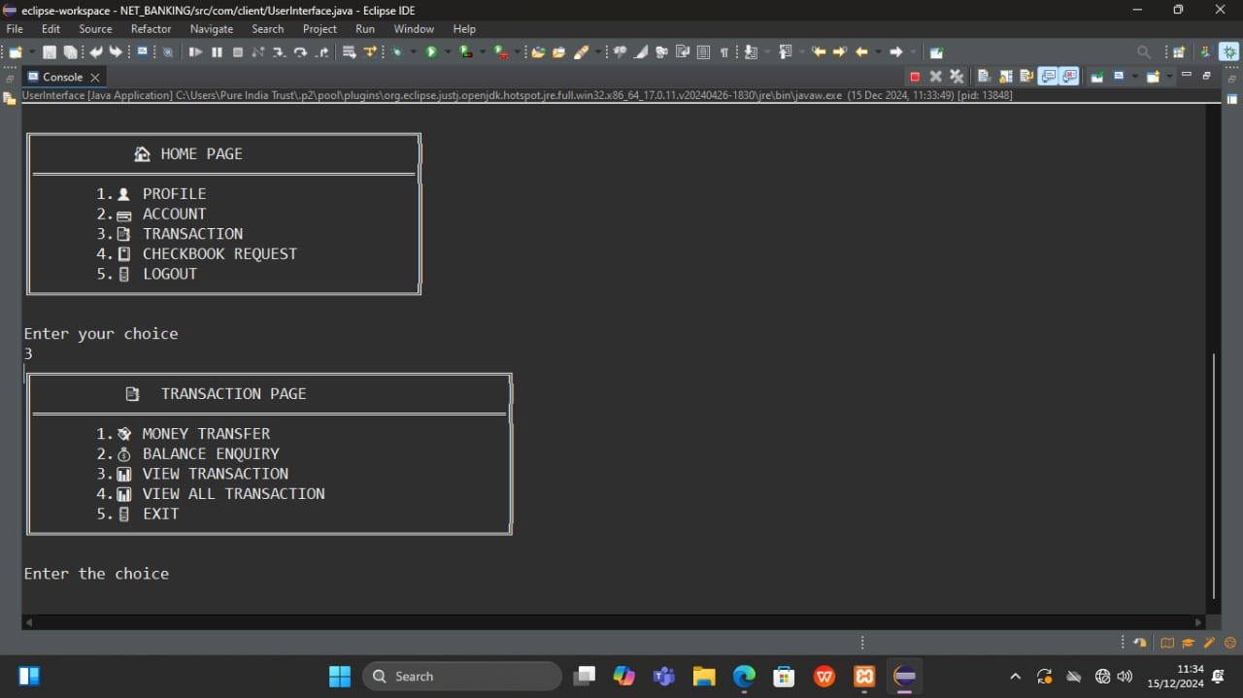

1. **Money Transfer:**
   * Navigate to **Transaction**.
   * Select **Money Transfer**.
   * Enter recipient details and transfer amount.
2. **Balance Enquiry:**
   * Access **Balance Enquiry** under **Transaction**.
   * View the current balance of your account.
3. **View Transaction Details:**
   * Select **View Transactions**.
   * Check transaction history for a specific period.
4. **View All Transactions:**
   * Navigate to **View All Transactions**.
   * Displays a comprehensive list of all transactions performed on your account, including date, amount, and transaction type.
5. **Exit to Home Page:**
   * Select **Exit** to return to the home page.

### Checkbook Request Management:

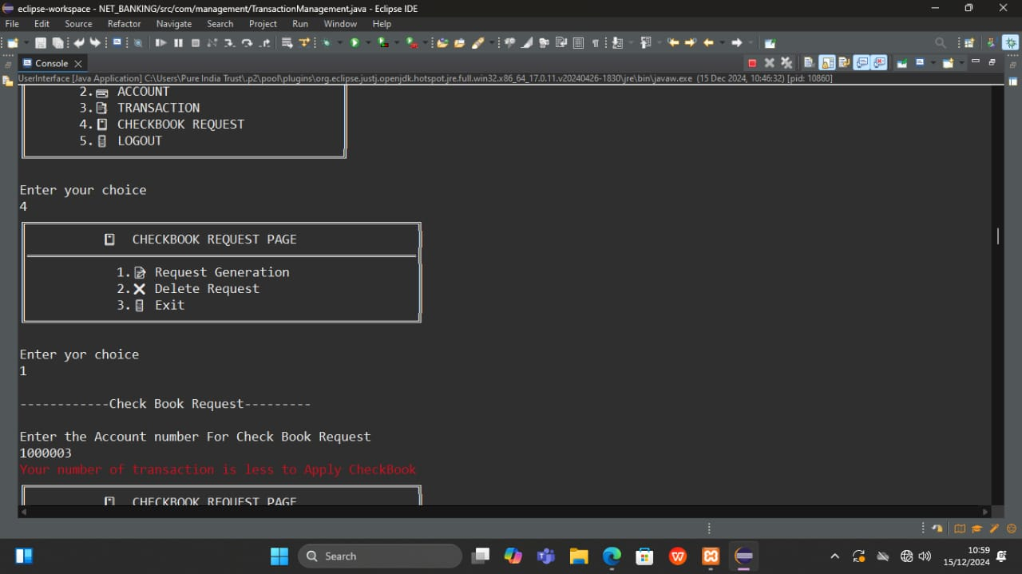

1. **Request Checkbook:**

* Navigate to **Checkbook Management** from the home page.
* To request a checkbook, the following conditions must be met:
  1. Your transaction count should be more than 5.
  2. Your account balance should be at least ₹2,00,000.
* Confirm your request if the conditions are satisfied.

1. **Delete Request:**
   * Go to **Delete Request** under **Checkbook Management**.
   * Cancel any previously submitted checkbook request if it is no longer needed.
2. **Exit to Home Page:**
   * Select **Exit** to return to the home page.

.